INTEGRATIVE COURSE IN PSYCHOLOGY (ICOPSYCH)

ANALYSIS ON THE RESULT OF PRE-TEST EXAMINATION IN INDUSTRIAL PSYCHOLOGY
MARCH 22, 2025

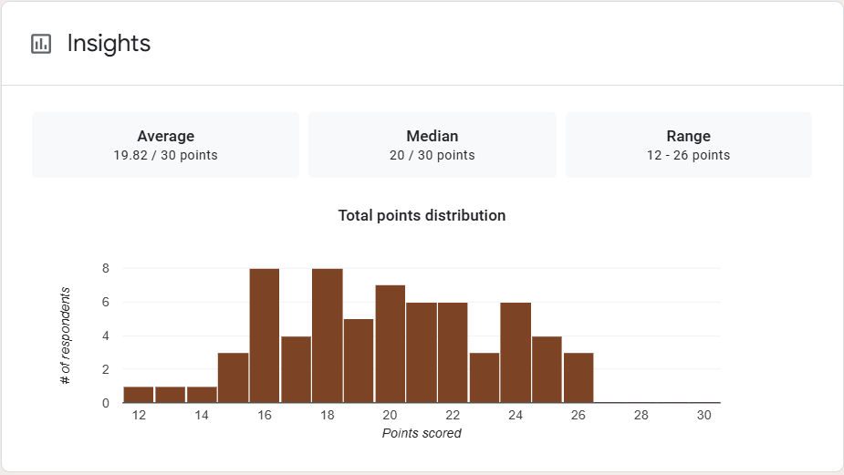

1. Mean Score: The average score of all the participants is approximately 19.82 out of 30. This indicates that, on average, most of the individuals scored just below the halfway point of the total possible score, suggesting that the exam may have been moderately difficult.

2. Median Score: The median score of 20 out of 30 suggests that half of the participants scored below 20, while half scored above 20. The median being close to the mean suggests a relatively symmetric distribution of scores, meaning there wasn't a significant skew in performance (i.e., most students scored either slightly below or above the average).

3. Range: The lowest score was 12 out of 30, and the highest was 26 out of 30, giving a range of 14 points. This indicates there was some variation in performance, with a gap of 14 points between the lowest and highest scores, showing that there were both higher and lower performers.

Interpretation Summary:

-The average and median scores are relatively close, which suggests a fairly balanced performance across the participants.

- The scores ranged from 12 to 26, indicating some variation, but the bulk of participants were likely concentrated around the middle of the score distribution.

- Overall, this suggests that the exam may have been of moderate difficulty, with most participants performing in a similar range around the 20-point mark.

RATIONALIZATION:

DIFFICULT QUESTIONS:

